PHOTOGRAPHIC ESSAY

Name: Moses Kamau
Registration Number: C025-01-2511/2021
Program: Bachelor of Science in Information Technology
Dedan Kimathi University of Technology
Date: February, 2026

ESSAY OVERVIEW

This photographic essay presents a visual narrative of my journey from a curious child in Othaya to a final-year IT student about to graduate from Dedan Kimathi University of Technology. Through five thematic series comprising of carefully selected photographs, this essay tells the story of transformation, innovation, and the intersection of technology with African culture and community.

SERIES 1: MY UNIVERSITY JOURNEY AT DEKUT
Walking through the gates of Dedan Kimathi University of Technology in September 2021, I felt both excitement and nervousness. I had dropped out of Industrial Mathematics at JKUAT mid-program because my heart wasn't in it. This was my fresh start, my chance to finally study what I was passionate about - Information Technology. I was 22, starting over, and determined to make it count.
Those first few weeks were humbling. I thought I knew computers because I'd taught myself coding in secondary school. But Introduction to Programming in C++ showed me how much I didn't know. Object-oriented programming, data structures, algorithms - these were completely new concepts.
The COVID-19 period hit during first year, forcing us online. It was frustrating - spotty internet at home, trying to focus with distractions everywhere. But looking back, it forced me to become more independent, more resourceful. I learned to use Zoom, to collaborate remotely, to solve problems when I couldn't just walk to a lab and ask for help.
Second and third year were about building. Database Systems taught me to think in tables and relationships. Web Development showed me the magic of seeing code transform into actual websites. The group projects - the Student Management System, the church donation tracker - these taught me that good code isn't just about making something work. It's about understanding what people actually need.
Third year brought the reality check. I applied for internships and got rejected. The feedback was consistent: "You need more practical project experience." That stung, but it lit a fire. It's why I chose such an ambitious capstone project. I wasn't going to graduate with just theory.
Fourth year and the B-FIT GYM Manager project under Dr. Mbuki Maina's supervision became the culmination of everything. Every lesson from four years came together. The programming fundamentals from first year, the database design from second year, the mobile-first thinking from third year, all of it. The late nights debugging, the frustration of CORS errors, the triumph of finally integrating M-Pesa - this was where student became developer.
DeKUT didn't just teach me to code. It taught me to see problems and build solutions. It taught me that technology should serve people, not the other way around. And most importantly, it gave me the confidence that I belong in this field. That kid who walked through the gates uncertain in 2021 is walking out in 2026 ready to build the future.

Photograph 1: Computer Lab session
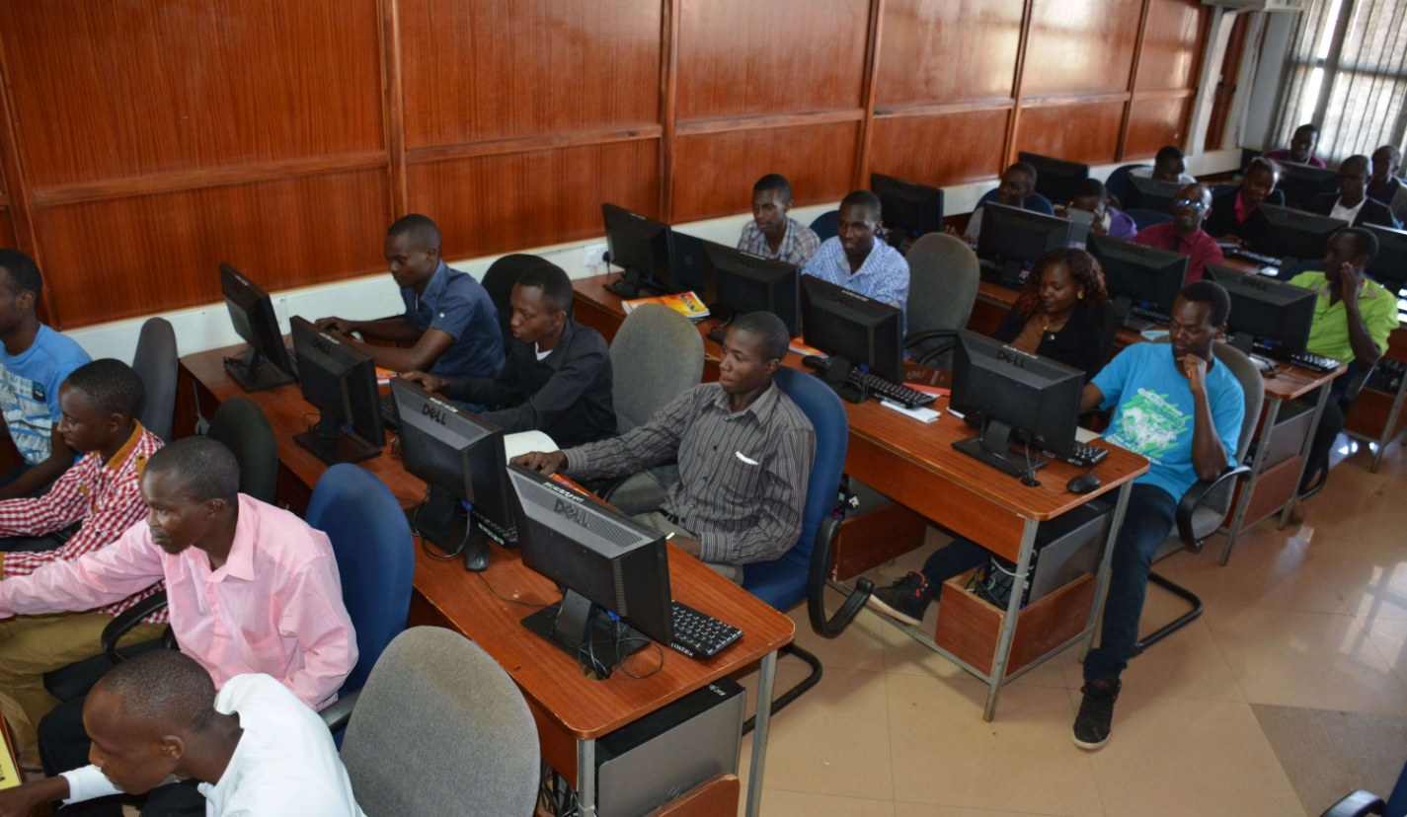

SERIES 2: BUILDING B-FIT GYM MANAGER
The idea for B-FIT GYM Manager didn't come from a textbook or assignment prompt. It came from standing in line at my local gym in Nyeri in January 2023, watching a frustrated member argue with the manager about a payment that couldn't be found in the paper ledger. The dispute went on for half an hour, holding up everyone, creating tension. In that moment, I saw not just a problem, but an opportunity to apply everything I'd learned at DeKUT to create something genuinely useful.
I started researching. I visited five different gyms in Nyeri, talked to owners, staff, and members. The pattern was clear - they all struggled with the same issues. Paper records that got lost. Manual attendance tracking that wasted time. Cash payments with no reliable trail. They wanted digital solutions but assumed anything good would be too expensive. That's when I knew - this would be my capstone project.
February to April 2024 was planning and design. I sketched database schemas on paper, drew interface mockups, chose my tech stack carefully. React.js for the frontend because it's what I knew best. Node.js for the backend to keep everything in JavaScript. JSON file storage because it's simple and affordable for small gyms. QR codes for attendance because any smartphone can scan them - no expensive biometric hardware needed. Every decision was filtered through one question: "Will this work for a small Kenyan gym?"
Development started in May. The member interface came first - login, profiles, viewing subscription status. Then the backend logic - saving member data, processing payments, tracking attendance. I built the QR code system next, then the admin dashboard where owners could see everything at a glance. Each feature worked in isolation, but connecting them all? That's where the real challenges hit.
CORS errors blocked my frontend-backend communication for days. I searched Stack Overflow, asked classmates, debugged line by line until finally understanding the issue and fixing it. The M-Pesa Daraja API integration proved even harder - authentication, callback URLs, testing with actual transactions. But persistence paid off. By February 2025, I had a working system.
Testing with actual gym members was humbling. They found bugs I'd never anticipated. The interface that seemed intuitive to me confused them. Their feedback led to over a dozen improvements. This taught me something crucial - good technology isn't about clever code. It's about solving real problems for real people in ways they can actually use.
B-FIT transformed me. I stopped being just a student learning concept. I became a developer who could see a problem in the world, design a solution, and build something that creates value. That gym dispute that started it all? B-FIT ensures it never happens again. Digital records, automatic tracking, M-Pesa integration. That's what makes me proudest.

Photograph 2: B-FIT Login Interface
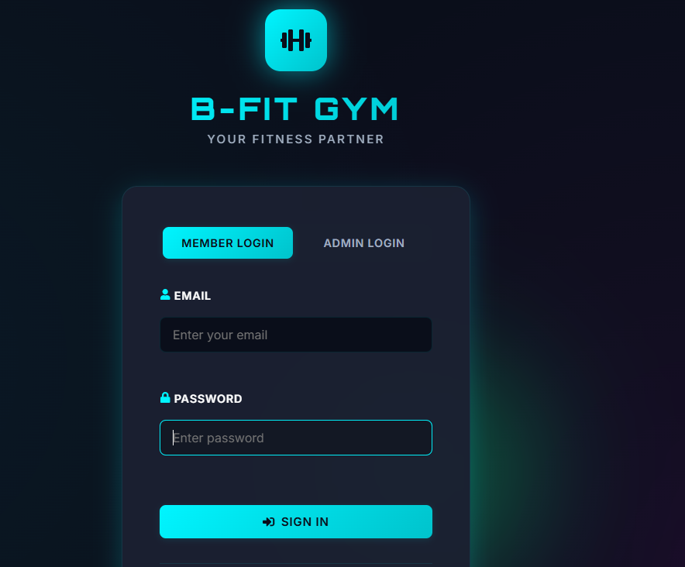

SERIES 3: TECHNOLOGY IN MY COMMUNITY
When I visit my grandmother in our village in Othaya, I'm always struck by the quiet revolution happening around her. She's in her seventies, has never owned a computer, never sent an email, yet she uses M-Pesa multiple times a week. She sends money to relatives in Nairobi, pays for groceries at the local shop, even pays her church tithe - all from her basic phone. This isn't happening in Silicon Valley. This is African innovation, happening right here.
Kenya didn't follow the Western technology path. We didn't wait for landlines to reach every home, then add mobile phones later. We leapfrogged directly to mobile. We didn't build bank branches in every village, then add digital banking. M-Pesa became our financial infrastructure. This mobile-first reality shaped how I think about building technology.
In Nyeri town, every small shop displays "M-Pesa accepted here" signs. The mama mboga selling vegetables has a smartphone for payments. The matatu conductor uses mobile money. The cyber café owner charges phones using solar panels. Technology isn't something separate from daily life - it's woven into how business happens, how families stay connected, how communities function.
This context fundamentally shaped B-FIT. I didn't build for ideal conditions with reliable internet and expensive hardware. I built for the reality I see every day - mobile phones, spotty connectivity, M-Pesa payments, affordable solutions. The best technology for Africa comes from people who understand African reality. That's what these photos show - technology serving real people in real communities, not as a luxury but as practical tools for daily life.

Photograph 3: M-Pesa Agent Shop in Nyeri Town
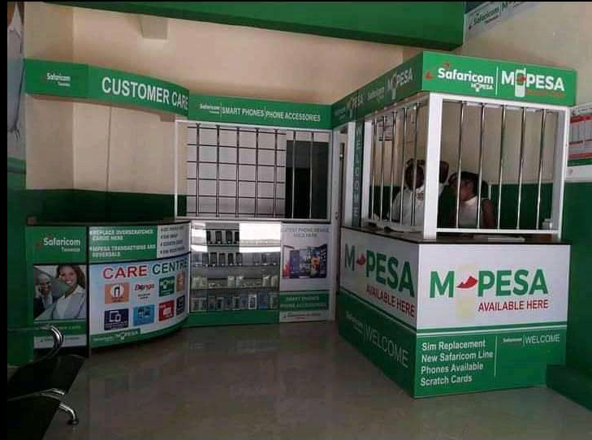

SERIES 4: ROOTS AND HERITAGE - OTHAYA
Othaya, in Nyeri County, is where my story begins. Rolling hills, coffee plantations, tight-knit communities where everyone knows everyone. It's where I first saw my father repair a radio and wondered how sound traveled through air. It's where teachers at St. Teresa Kanyange Academy first sat me down in front of a computer in Class 4. And it's the place that taught me the value of community - of Ubuntu - of using your abilities to lift others.
My parents worked hard to give me an education, even when my world of code and apps sounded like a foreign language to them. Their simple advice was "keep learning" and it became my compass. When I switched from Industrial Mathematics to IT, starting over at 22, they supported that decision. They believed in the power of education even when they didn't fully understand what I was studying.
Growing up in Othaya taught me that technology should serve people, not impress them. The solutions that matter aren't the most sophisticated. They're the ones that work for real communities with real constraints. When I build B-FIT, I think about small gym owners in towns like Nyeri who need affordable tools, not expensive enterprise software.
I carry Othaya with me. The Ubuntu philosophy, the community values, the understanding that individual success means nothing if your community struggles. As I graduate and move forward, I carry the responsibility to give back, to mentor others from similar backgrounds, to prove that where you come from doesn't limit where you can go. Othaya made me who I am. Now it's my turn to make Othaya proud.

Photograph 4: Landscape of Othaya, Nyeri County
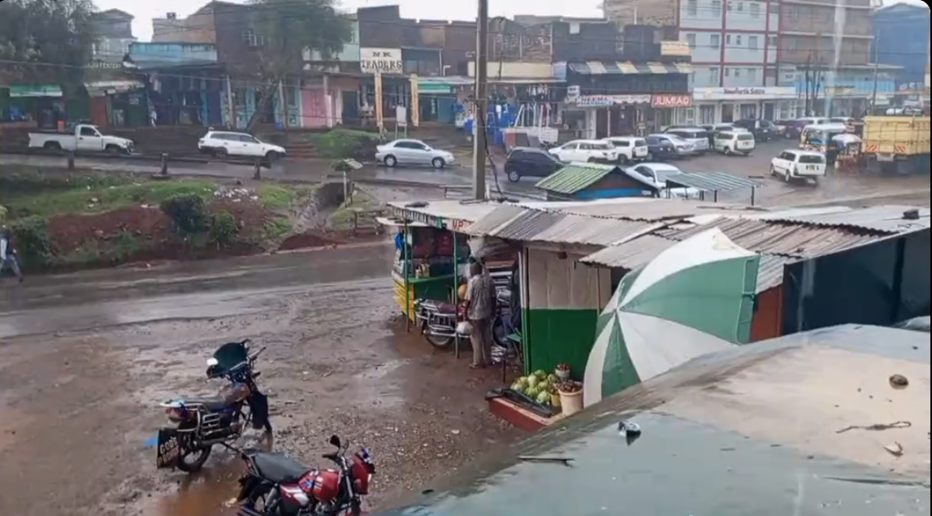

SERIES 5: FUTURE ASPIRATIONS
As I stand at the threshold of graduation, I'm filled with excitement about what comes next. This degree isn't just a certificate - it's proof of capability. The ability to see problems, design solutions, and build tools that create value.
My vision is clear: build technology that serves African markets. Not copying Western solutions, but creating contextually appropriate tools that work for our realities - mobile-first, affordable, integrated with M-Pesa, designed for spotty connectivity. B-FIT is just the beginning.
Short-term, I'm seeking a junior developer position where I can grow my skills while contributing immediately. I want to master additional technologies. React Native for mobile apps, Python for data work, cloud platforms for scaling solutions. And I want to enhance B-FIT. Deploying it to real gyms, adding the features I envisioned but didn't have time to build.
Long-term, I see myself as a technical leader who mentors younger developers, someone known for building practical solutions for African challenges. I want to guide students the way my teachers guided me. I want to prove that the best solutions for Africa come from Africans who understand our context, our culture, our opportunities.
CONCLUSION: THE COMPLETE JOURNEY
This photographic essay serves as the final capstone project deliverable for the Bachelor of Science in Information Technology program at Dedan Kimathi University of Technology.

